10. Investigation of Coefficient and Product Quantization Noise and Limit-Cycle Oscillations Using MATLAB
Objectives of this Experiment:
1. To investigate coefficient quantization and product quantization in a digital filter.
2. To measure the effect of finite word length on the filter response and output signal.
3. To demonstrate zero-input and overflow limit-cycle oscillations.
4. To evaluate the resulting quantization noise and performance degradation.
PROGRAM CODE:
clc; clear; close all;

%% INPUTS
b = [0.0048 0.0193 0.0289 0.0193 0.0048];
a = [1 -2.3695 2.3140 -1.0547 0.1874];

Bc = 8; % Coefficient word length
Bp = 16; % Product word length
N = 200;
x = [1 zeros(1,N-1)]; % Unit impulse

%% 1. COEFFICIENT QUANTIZATION
S = 2^(Bc-1)-1;
bq = round(b*S)/S;
aq = round(a*S)/S;

CoeffError = [b-bq, a-aq];

%% 2. IDEAL AND COEFFICIENT-QUANTIZED RESPONSE
y_ideal = filter(b,a,x);
y_coeff = filter(bq,aq,x);

e_coeff = y_ideal - y_coeff;
MaxCoeffError = max(abs(e_coeff));
SQNR_coeff = 10*log10(sum(y_ideal.^2)/sum(e_coeff.^2));

%% 3. PRODUCT QUANTIZATION
Sp = 2^(Bp-1)-1;
y_prod = zeros(1,N);
v = zeros(1,4);

for n = 1:N
p = bq*x(n);
fb = -aq(2:5).*v;
p = round([p fb]*Sp)/Sp; % Product quantization
y_prod(n) = sum(p);
v = [y_prod(n) v(1:3)];
end

e_prod = y_coeff - y_prod;
MaxProdError = max(abs(e_prod));
SQNR_prod = 10*log10(sum(y_coeff.^2)/sum(e_prod.^2));

%% 4. ZERO-INPUT LIMIT-CYCLE TEST
x0 = zeros(1,N);
state = [0.01 0.01 0.01 0.01];
y_zero = zeros(1,N);

for n = 1:N
acc = -aq(2:5)*state.';
y_zero(n) = round(acc*Sp)/Sp;
state = [y_zero(n) state(1:3)];
end

LimitAmplitude = max(abs(y_zero));

%% 5. OVERFLOW / SATURATION TEST
xo = 1.2*ones(1,N);
y_over = filter(bq,aq,xo);
y_sat = min(max(y_over,-1),1); % Normalized saturation

OverflowCount = sum(abs(y_over)>1);
MaxOverflow = max(abs(y_over));

%% 6. OUTPUT SUMMARY DISPLAY
fprintf('\n--- QUANTIZATION RESULTS ---\n');
fprintf('Maximum coefficient/output error = %.6e\n', MaxCoeffError);
fprintf('Coefficient SQNR = %.2f dB\n', SQNR_coeff);
fprintf('Maximum product quantization error = %.6e\n', MaxProdError);
fprintf('Product SQNR = %.2f dB\n', SQNR_prod);
fprintf('Zero-input maximum amplitude = %.6e\n', LimitAmplitude);
fprintf('Overflow samples = %d\n', OverflowCount);

T = table( ...
["Coefficient Quantization"; "Product Quantization"; "Zero-Input Test"; "Overflow Test"], ...
[MaxCoeffError; MaxProdError; LimitAmplitude; MaxOverflow], ...
[SQNR_coeff; SQNR_prod; NaN; NaN], ...
'VariableNames', {'Test', 'Maximum_Error_or_Amplitude', 'SQNR_dB'});
disp(T);

%% 7. COEFFICIENTS DISPLAY
disp('Original b ='); disp(b);
disp('Quantized b ='); disp(bq);
disp('Original a ='); disp(a);
disp('Quantized a ='); disp(aq);

%% 8. PLOTS
figure('Name', 'Ideal vs Quantized Impulse Response');
stem(0:N-1, y_ideal, 'filled'); hold on;
stem(0:N-1, y_coeff);
grid on; xlabel('n'); ylabel('Amplitude');
title('Ideal vs Coefficient-Quantized Response');
legend('Ideal','Quantized');

figure('Name', 'Quantization Noises');
subplot(2,1,1);
plot(0:N-1, e_coeff, 'LineWidth', 1);
grid on; xlabel('n'); ylabel('Error');
title('Coefficient Quantization Noise');

subplot(2,1,2);
stem(0:N-1, e_prod, 'filled');
grid on; xlabel('n'); ylabel('Error');
title('Product Quantization Noise');

figure('Name', 'Zero-Input Limit Cycle');
plot(0:N-1, y_zero, 'LineWidth', 1);
grid on; xlabel('n'); ylabel('Amplitude');
title('Zero-Input Limit-Cycle Test');

figure('Name', 'Saturation Test');
plot(0:N-1, y_over); hold on;
plot(0:N-1, y_sat, '--');
grid on; xlabel('n'); ylabel('Amplitude');
title('Overflow / Saturation Test');
legend('Without Saturation','With Saturation');

figure('Name', 'Quantized Pole-Zero Plot');
zplane(bq, aq); grid on;
title('Quantized Filter Pole-Zero Plot');
OUTPUT: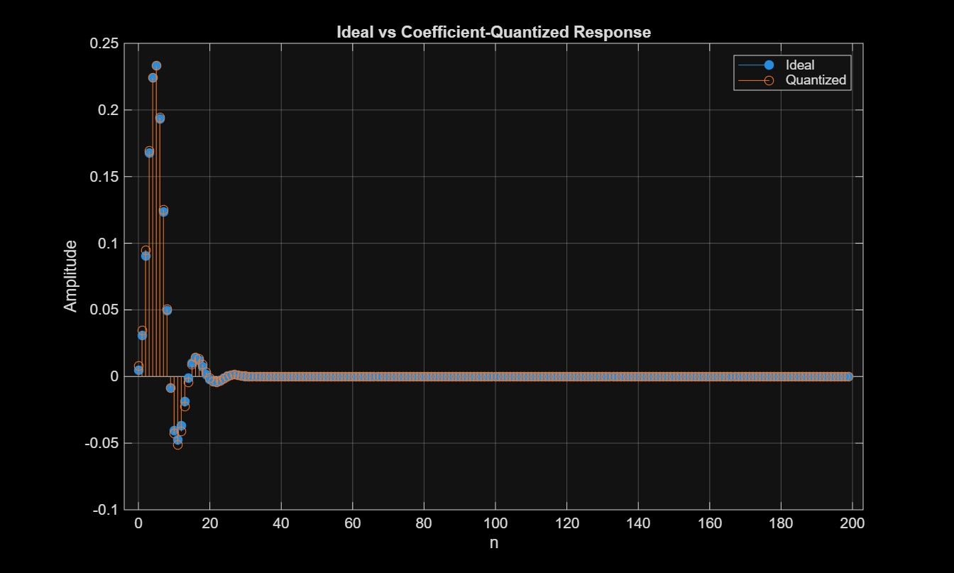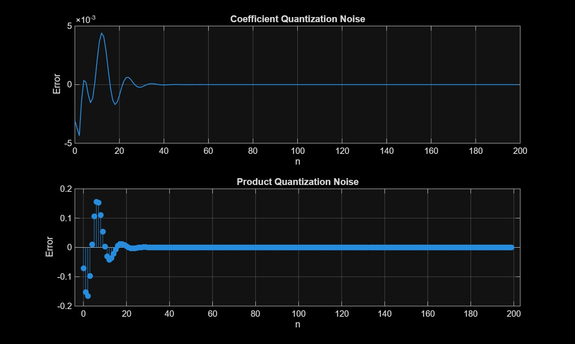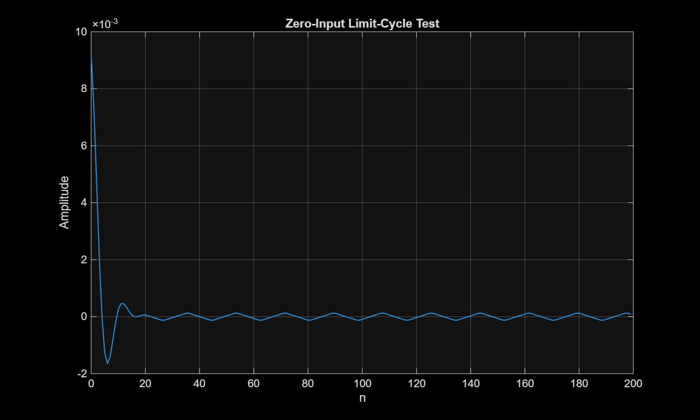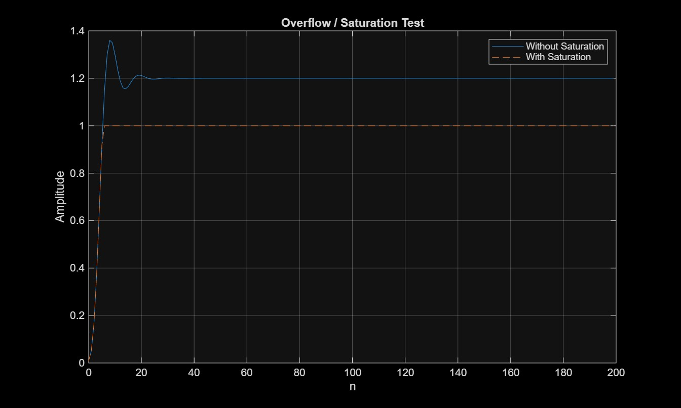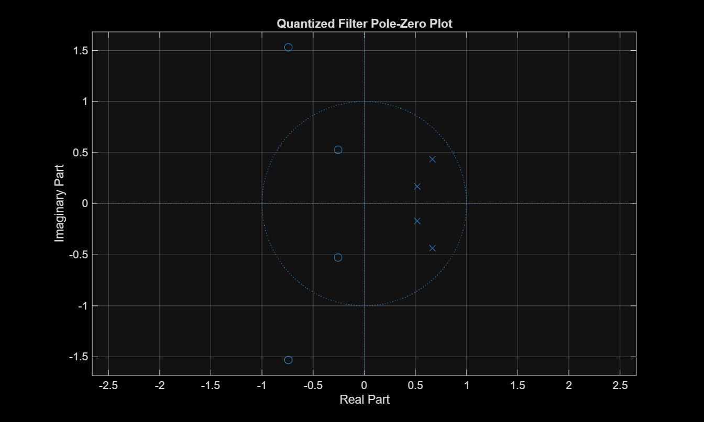
RESULT:

--- QUANTIZATION RESULTS ---
Maximum coefficient/output error = 4.405764e-03
Coefficient SQNR = 32.23 dB
Maximum product quantization error = 1.651951e-01
Product SQNR = 1.57 dB
Zero-input maximum amplitude = 9.216590e-03
Overflow samples = 194
Test Maximum_Error_or_Amplitude SQNR_dB
__________________________ __________________________ _______

"Coefficient Quantization" 0.0044058 32.233
"Product Quantization" 0.1652 1.5673
"Zero-Input Test" 0.0092166 NaN
"Overflow Test" 1.3599 NaN

Original b =
0.0048 0.0193 0.0289 0.0193 0.0048

Quantized b =
0.0079 0.0157 0.0315 0.0157 0.0079

Original a =
1.0000 -2.3695 2.3140 -1.0547 0.1874

Quantized a =
1.0000 -2.3701 2.3150 -1.0551 0.1890

>>

